📘 Chapter 12 – CSS 3D Transforms: Zameen Aasmaan Ghuma Denge 🌍

🧾 What is 3D Transform?
3D transform CSS me element ko X, Y ke saath Z axis pe bhi control karne deta hai.
Matlab:
- X → left/right
- Y → up/down
- Z → andar/bahar (3rd dimension!) 😲

🌀 Basic 3D Properties:
Property | Kya karta hai
rotateX(deg) | X-axis ke around ghumata hai
rotateY(deg) | Y-axis ke around ghumata hai
rotateZ(deg) | Z-axis ke around (normal 2D rotate)
perspective | 3D ka depth effect deta hai
transform-style | Child elements 3D me dikhaye ya flat

🧪 Example 1: RotateX – Palti Maarna
<div style="transform: rotateX(45deg); background: orange; padding: 20px;">
🔄 RotateX(45deg) – Aage ko Jhuka
</div>

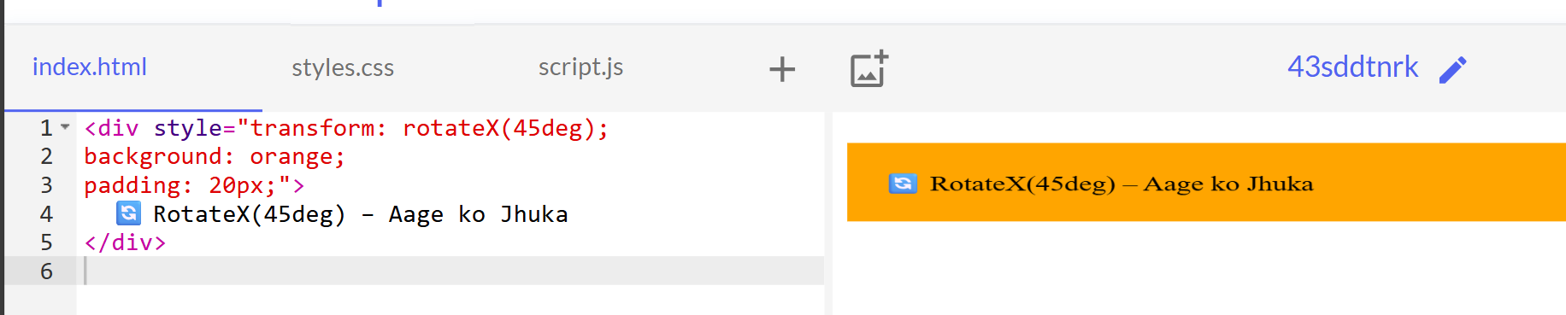

🧪 Example 2: RotateY – Side Se Dikhega
<div style="transform: rotateY(60deg); background: tomato; padding: 20px;">
🔁 RotateY(60deg) – Side View Aaya
</div>

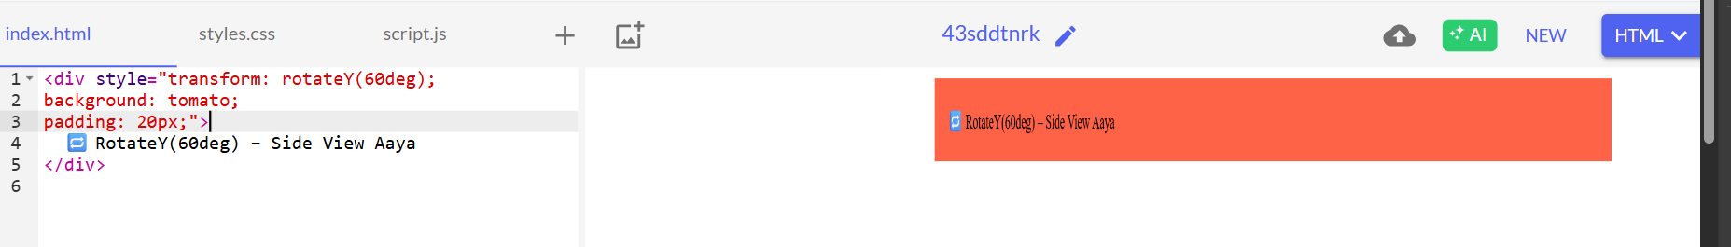

👀 Perspective – 3D Depth Feel Deta Hai
perspective: parent pe lagate hain
Depth control karta hai – jaise camera distance
<div style="perspective: 800px;">
<div style="transform: rotateY(60deg); background: purple; padding: 20px; color: white;">
👁️ Yeh 3D depth ke saath ghooma
</div>
</div>
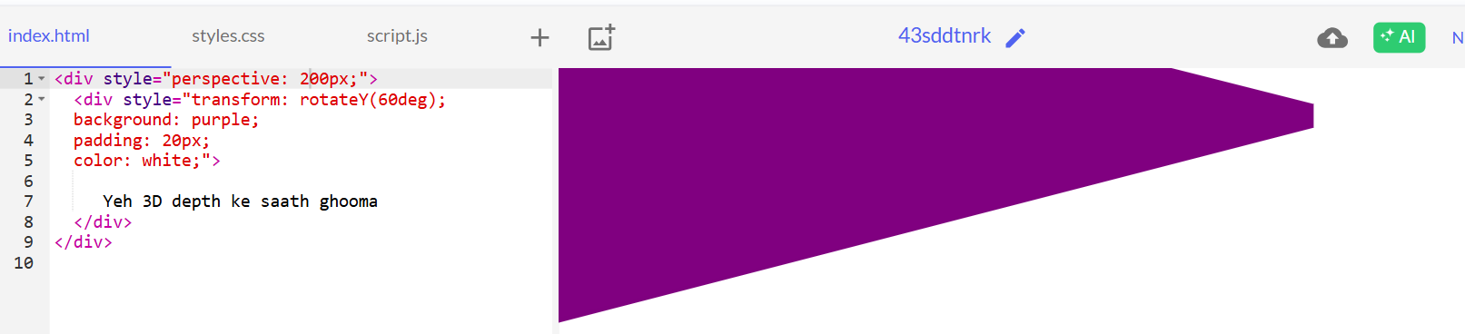

🧠 Lower value = zyada depth
perspective: 300px = zyada zoom
perspective: 1000px = halka zoom

💫 Example: 3D Flip Card

Click me

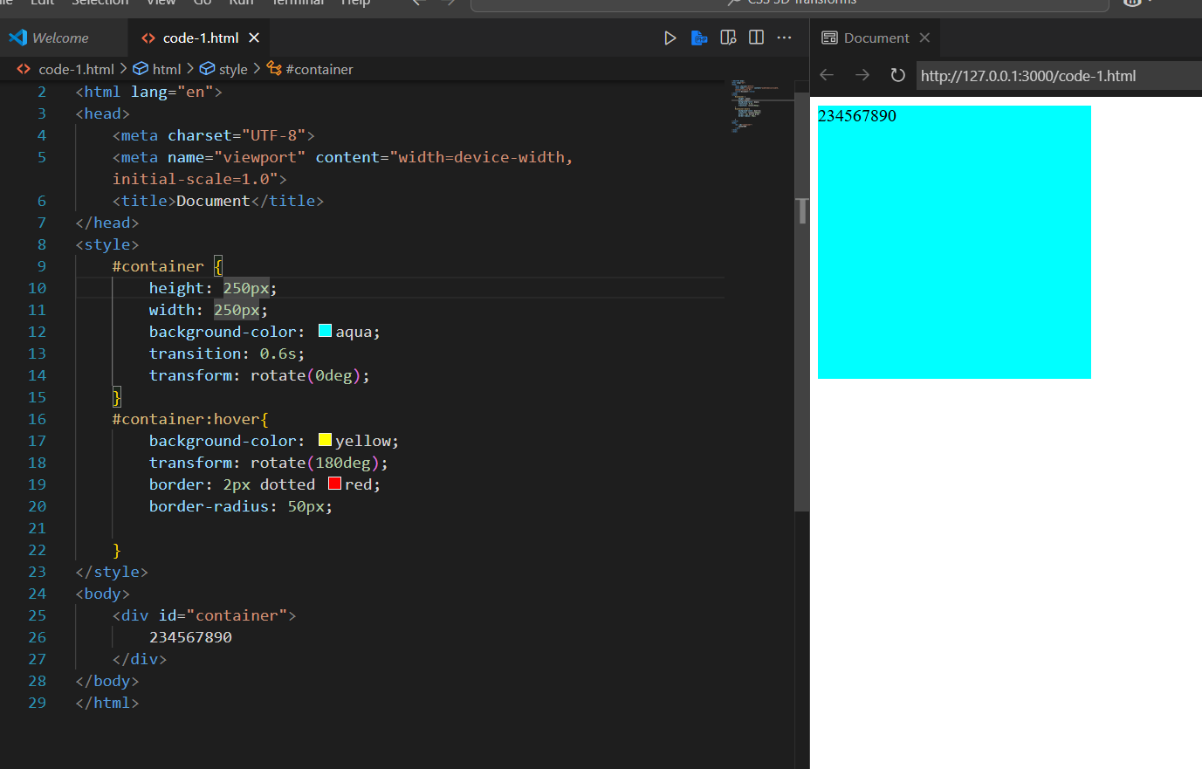

Code -2

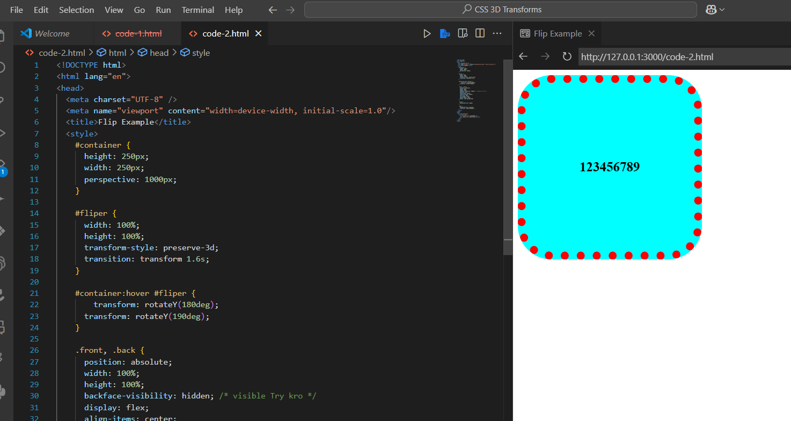

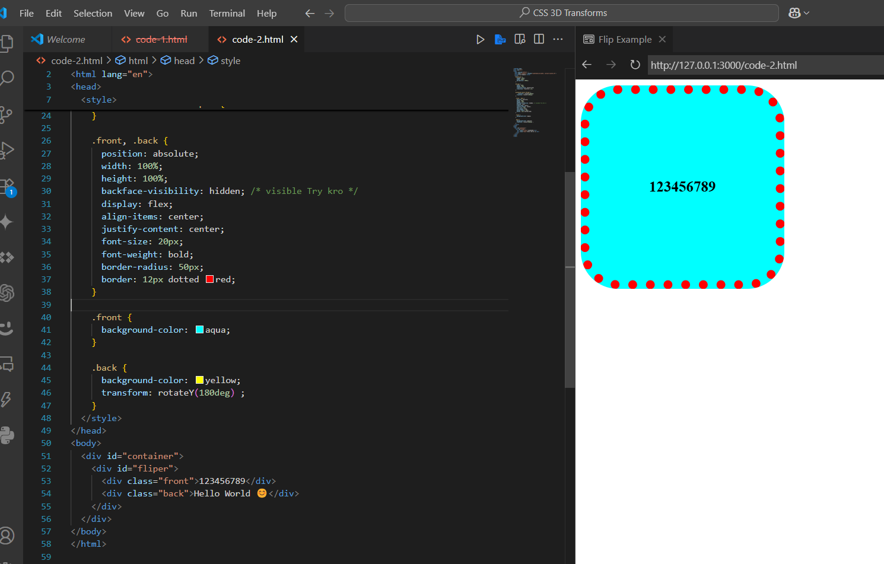

After hover
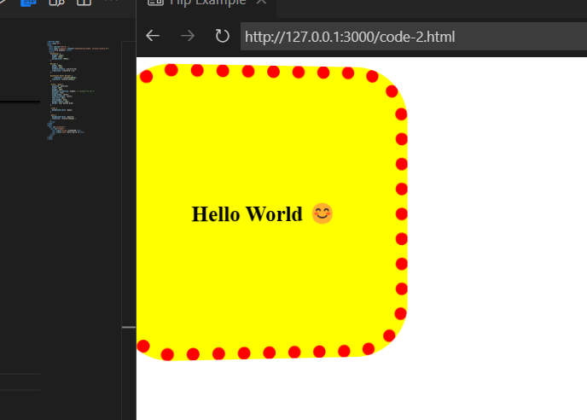

Click me
<style>
.flip-container {
perspective: 1000px;
width: 200px;
height: 200px;
}

.flipper {
width: 100%;
height: 100%;
position: relative;
transition: 0.6s;
transform-style: preserve-3d;
}

.flip-container:hover .flipper {
transform: rotateY(180deg);
}

.front, .back {
position: absolute;
width: 100%;
height: 100%;
backface-visibility: hidden;
display: flex;
align-items: center;
justify-content: center;
font-size: 18px;
color: white;
}

.front {
background: #3498db;
}

.back {
background: #e74c3c;
transform: rotateY(180deg);
}
</style>

<div class="flip-container">
<div class="flipper">
<div class="front">😎 Front Side</div>
<div class="back">😲 Back Side</div>
</div>
</div>

📝 Summary:
- rotateX() → X-axis (up/down palti)
- rotateY() → Y-axis (left/right ghuma)
- rotateZ() → Normal 2D rotate
- perspective: → Parent pe lagao for depth
- transform-style: preserve-3d; → Childs ko bhi 3D dikhne do
- backface-visibility: hidden; → Piche wala invisible banao

